St. Paul Lutheran Church of Catonsville

Fourth Sunday of Easter
May 8, 2022
St. Paul Lutheran Church and School
2001 Old Frederick Road Catonsville, Maryland 21228
Church: 410-747-1897 School: 410-747-1924
www.stpaulcatonsville.org email: secretary@stpaulcatonsville.org
Pastor Gregory Alms
Renata O’Reilly, Organist & Choir Director

Jesus calls us to be a Lutheran community gathered around Word and Sacrament and sends us to reach the lost, disciple the saved, and care for our neighbors everywhere.
Welcome to worship in the name of our Lord Jesus Christ! If you are a guest with us today, we would like to extend a special greeting from our family. We invite you to worship with us; sing with us; pray with us; believe with us; for God has sent His Son to bring life and salvation. The ushers will be glad to answer any questions you have. If you have special prayer requests or would like a visit, they will also be able to assist you. Please enter your information using the QR code or sign our guest book before you depart today. Make worship and Bible study the center of your weekly life. Be here each Sunday, that we may rejoice in the Lord together! May God bless us!

For Those Who Desire to Receive The Lord’s Supper
The Lord’s Supper is celebrated at St. Paul in the confession and glad confidence that, as He says, our Lord gives into our mouths not only bread and wine but His very body and blood to eat and to drink for the forgiveness of sins and to strengthen our union with Him and with one another. Our Lord invites to His table those who trust His words, repent of all sin, and set aside any refusal to forgive and love as He forgives and loves us, that they may show forth His death until He comes.
Because those who eat and drink our Lord’s body and blood unworthily do so to their great harm and because Holy Communion is a confession of the faith which is confessed at this altar, any who are not yet instructed, in doubt or who hold a confession differing from that of this congregation and The Lutheran Church—Missouri Synod, and yet desire to receive the Sacrament, are asked first to speak with the pastor or an elder. For further study, see Matt. 5:23f.; 10:32f.; 18:15–35; 26:26–29; 1 Cor. 11:17–34. (Non-alcoholic wine is available in the center of the communion trays.)
Parents
- A changing table is available in both the Women’s and the Men’s bathroom.
- We welcome children in the worship service. If your child needs a break during the worship service, the Media Center is available to use. Turn right when you leave the sanctuary and follow the hall around to the Media Center. The service will be livestreamed in the Media Center so that you can still see and hear the worship service.
Children’s Bulletins: available in the narthex
Fourth Sunday of Easter
May 8, 2022

Prelude: We Walk by Faith and Not by Sight James Biery

605 Father Welcomes LSB 605
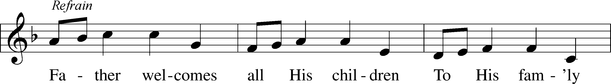
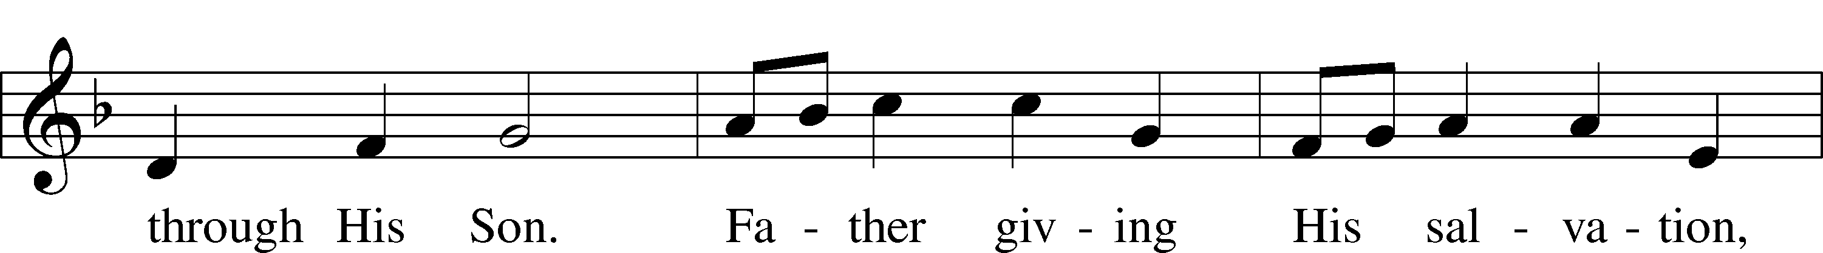
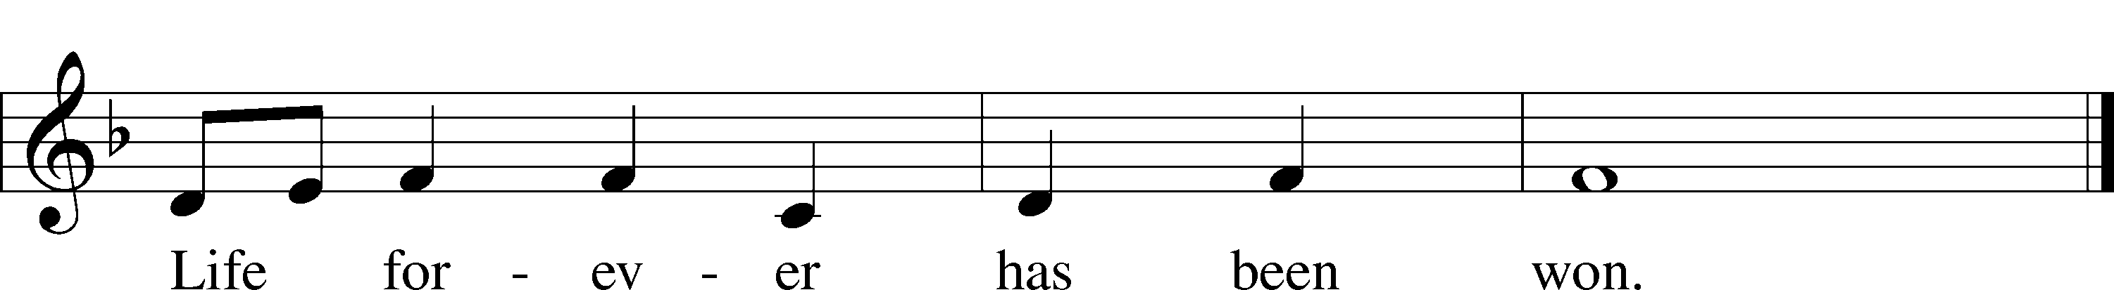
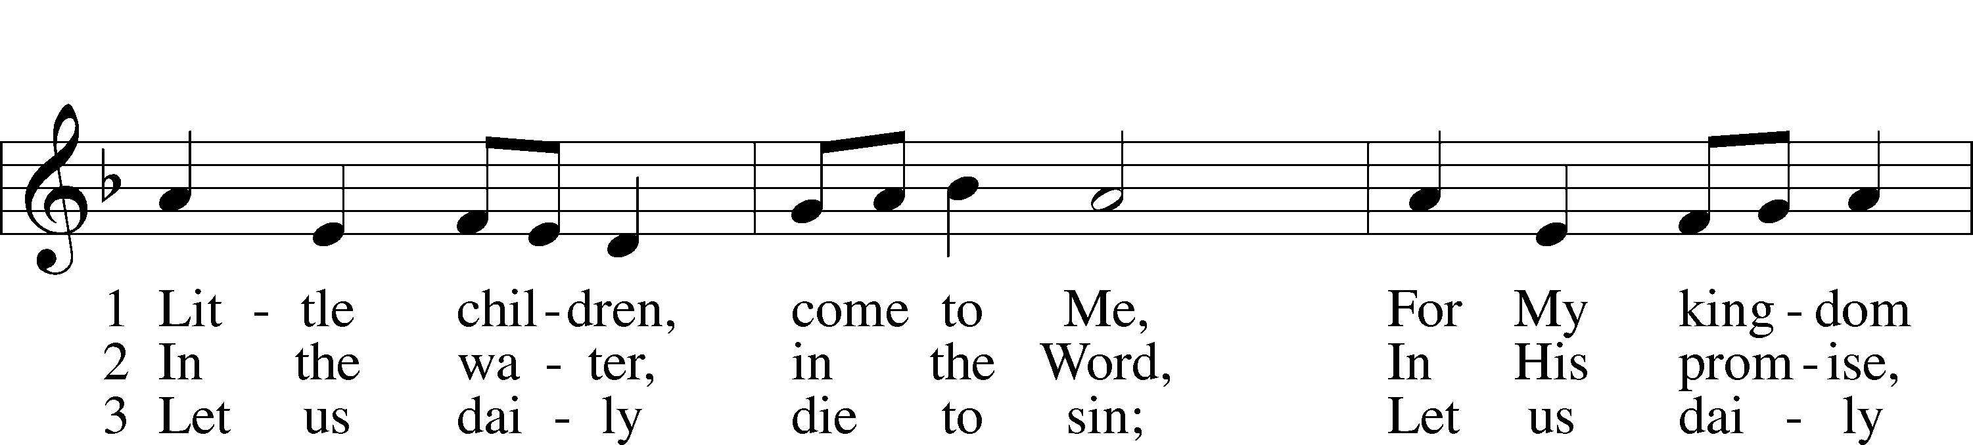
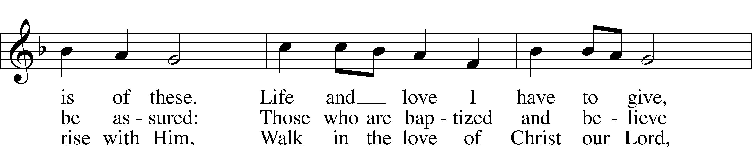
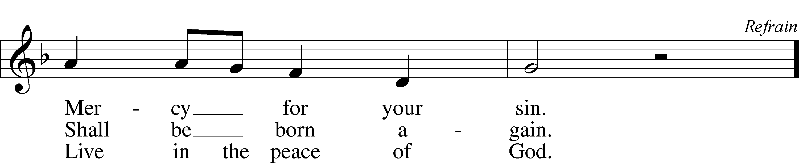
Text and tune: Robin Mann, 1949
Text and tune: © 1986 Kevin Mayhew Ltd. Used by permission: LSB Hymn License no. 110002320

Confession and Absolution
Invocation Matthew 28:19b; 18:20
P In the name of the Father and of the T Son and of the Holy Spirit.
C Amen.

Exhortation Psalm 124:8; Psalm 130:3–4; Luke 18:13
P Our help is in the name of the Lord,
C who made heaven and earth.

P If You, O Lord, kept a record of sins, O Lord, who could stand?
C But with You there is forgiveness; therefore You are feared.

P Since we are gathered to hear God’s Word, call upon Him in prayer and praise, and receive the body and blood of our Lord Jesus Christ in the fellowship of this altar, let us first consider our unworthiness and confess before God and one another that we have sinned in thought, word, and deed, and that we cannot free ourselves from our sinful condition. Together as His people let us take refuge in the infinite mercy of God, our heavenly Father, seeking His grace for the sake of Christ, and saying: God, be merciful to me, a sinner.

Kneel/Sit
Confession of Sins
C Almighty God, have mercy upon us, forgive us our sins, and lead us to everlasting life. Amen.

Absolution [John 20:19–23]
P Almighty God in His mercy has given His Son to die for you and for His sake forgives you all your sins. As a called and ordained servant of Christ, and by His authority, I therefore forgive you all your sins in the name of the Father and of the T Son and of the Holy Spirit.
C Amen.
Stand
Service of the Word
Kyrie Mark 10:47
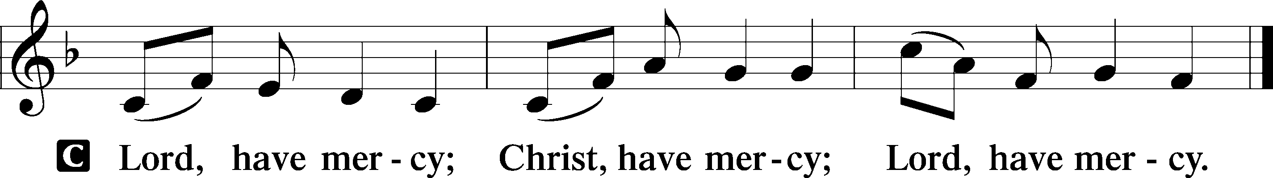
Gloria in Excelsis Luke 2:14; John 1:29
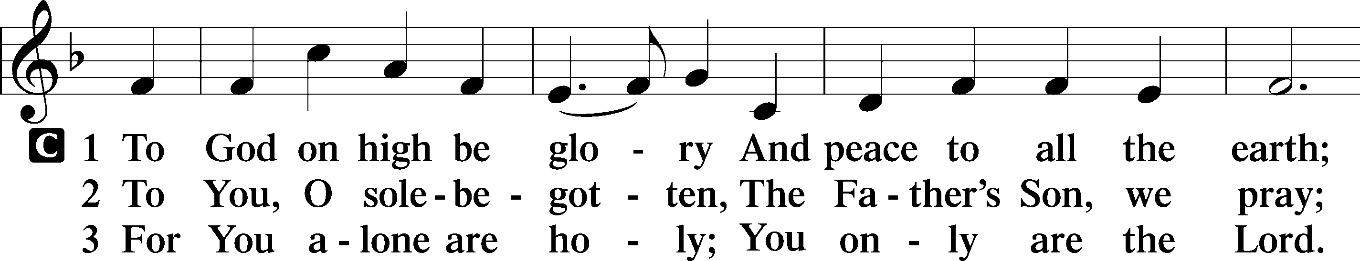
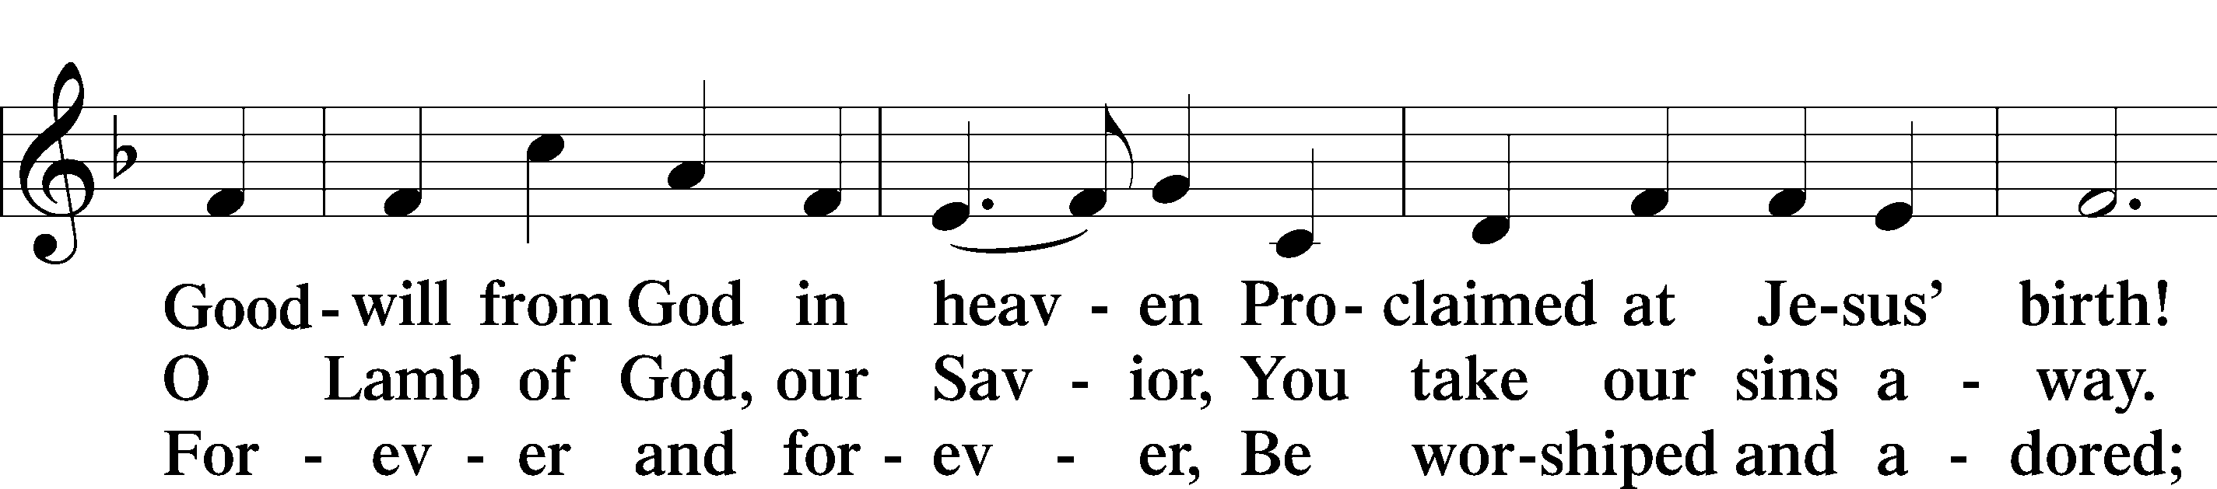
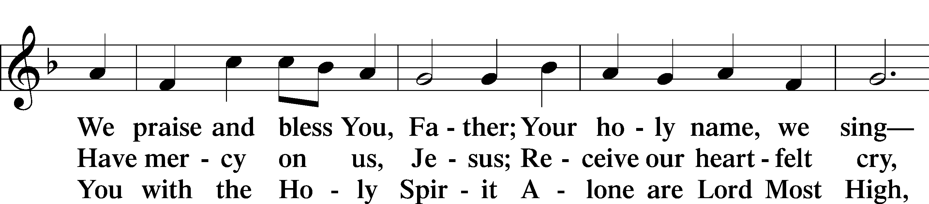
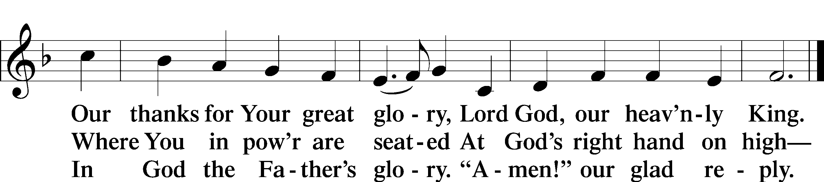
Text: Stephen P. Starke

Salutation and Collect of the Day
P The Lord be with you.
C And also with you.

P Let us pray.
C Almighty God, merciful Father, since You have wakened from death the Shepherd of Your sheep, grant us Your Holy Spirit that when we hear the voice of our Shepherd we may know Him who calls us each by name and follow where He leads; through the same Jesus Christ, Your Son, our Lord, who lives and reigns with You and the Holy Spirit, one God, now and forever. Amen.

Sit
Anthem: Jesu, the very thought of thee Glenn L. Rudolph
Jesu, the very thought of thee with sweetness fills the breast:
But sweeter far thy face to see, and in thy presence rest.
Nor voice can sing, nor heart can frame,
or can the memory find, a sweeter sound than thy blest name, O Saviour of Mankind.
Jesu, our only joy be thou, as thou our prize wilt be;
Jesu, be thou our glory now, and through eternity Amen.
First Reading Acts 20:17–35
17Now from Miletus [Paul] sent to Ephesus and called the elders of the church to come to him. 18And when they came to him, he said to them:
“You yourselves know how I lived among you the whole time from the first day that I set foot in Asia, 19serving the Lord with all humility and with tears and with trials that happened to me through the plots of the Jews; 20how I did not shrink from declaring to you anything that was profitable, and teaching you in public and from house to house, 21testifying both to Jews and to Greeks of repentance toward God and of faith in our Lord Jesus Christ. 22And now, behold, I am going to Jerusalem, constrained by the Spirit, not knowing what will happen to me there, 23except that the Holy Spirit testifies to me in every city that imprisonment and afflictions await me. 24But I do not account my life of any value nor as precious to myself, if only I may finish my course and the ministry that I received from the Lord Jesus, to testify to the gospel of the grace of God. 25And now, behold, I know that none of you among whom I have gone about proclaiming the kingdom will see my face again. 26Therefore I testify to you this day that I am innocent of the blood of all of you, 27for I did not shrink from declaring to you the whole counsel of God. 28Pay careful attention to yourselves and to all the flock, in which the Holy Spirit has made you overseers, to care for the church of God, which he obtained with his own blood. 29I know that after my departure fierce wolves will come in among you, not sparing the flock; 30and from among your own selves will arise men speaking twisted things, to draw away the disciples after them. 31Therefore be alert, remembering that for three years I did not cease night or day to admonish everyone with tears. 32And now I commend you to God and to the word of his grace, which is able to build you up and to give you the inheritance among all those who are sanctified. 33I coveted no one’s silver or gold or apparel. 34You yourselves know that these hands ministered to my necessities and to those who were with me. 35In all things I have shown you that by working hard in this way we must help the weak and remember the words of the Lord Jesus, how he himself said, ‘It is more blessed to give than to receive.’”

A This is the Word of the Lord.
C Thanks be to God.
Psalm 23 (spoken in unison) Psalm 23 (KJV)
The Lord is my shepherd;
I shall not want.
He maketh me to lie down in green pastures:
He leadeth me beside the still waters.
He restoreth my soul:
He leadeth me in the paths of righteousness for His name’s sake.
Yea, though I walk through the valley of the shadow of death,
I will fear no evil: for thou art with me;
Thy rod and thy staff, they comfort me.
Thou preparest a table before me in the presence of mine enemies:
Thou anointest my head with oil; my cup runneth over.
Surely goodness and mercy shall follow me all the days of my life:
and I will dwell in the house of the Lord forever.
Glory be to the Father and to the Son
and to the Holy Spirit;
as it was in the beginning,
is now, and will be forever. Amen.
Epistle Revelation 7:9–17
9After this I looked, and behold, a great multitude that no one could number, from every nation, from all tribes and peoples and languages, standing before the throne and before the Lamb, clothed in white robes, with palm branches in their hands, 10and crying out with a loud voice, “Salvation belongs to our God who sits on the throne, and to the Lamb!” 11And all the angels were standing around the throne and around the elders and the four living creatures, and they fell on their faces before the throne and worshiped God, 12saying, “Amen! Blessing and glory and wisdom and thanksgiving and honor and power and might be to our God forever and ever! Amen.”
13Then one of the elders addressed me, saying, “Who are these, clothed in white robes, and from where have they come?” 14I said to him, “Sir, you know.” And he said to me, “These are the ones coming out of the great tribulation. They have washed their robes and made them white in the blood of the Lamb.
15“Therefore they are before the throne of God,
and serve him day and night in his temple;
and he who sits on the throne will shelter them with his presence.
16They shall hunger no more, neither thirst anymore;
the sun shall not strike them,
nor any scorching heat.
17For the Lamb in the midst of the throne will be their shepherd,
and he will guide them to springs of living water,
and God will wipe away every tear from their eyes.”
A This is the Word of the Lord.
C Thanks be to God.

Stand
Gospel Processional Hymn: The King of Love My Shepherd Is LSB 709
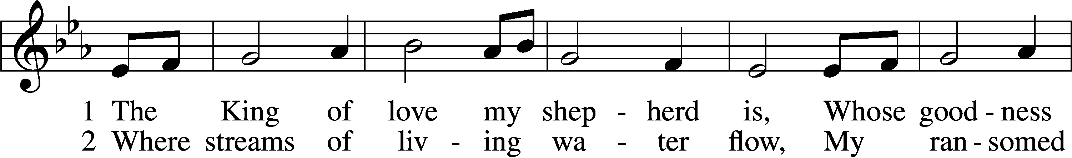
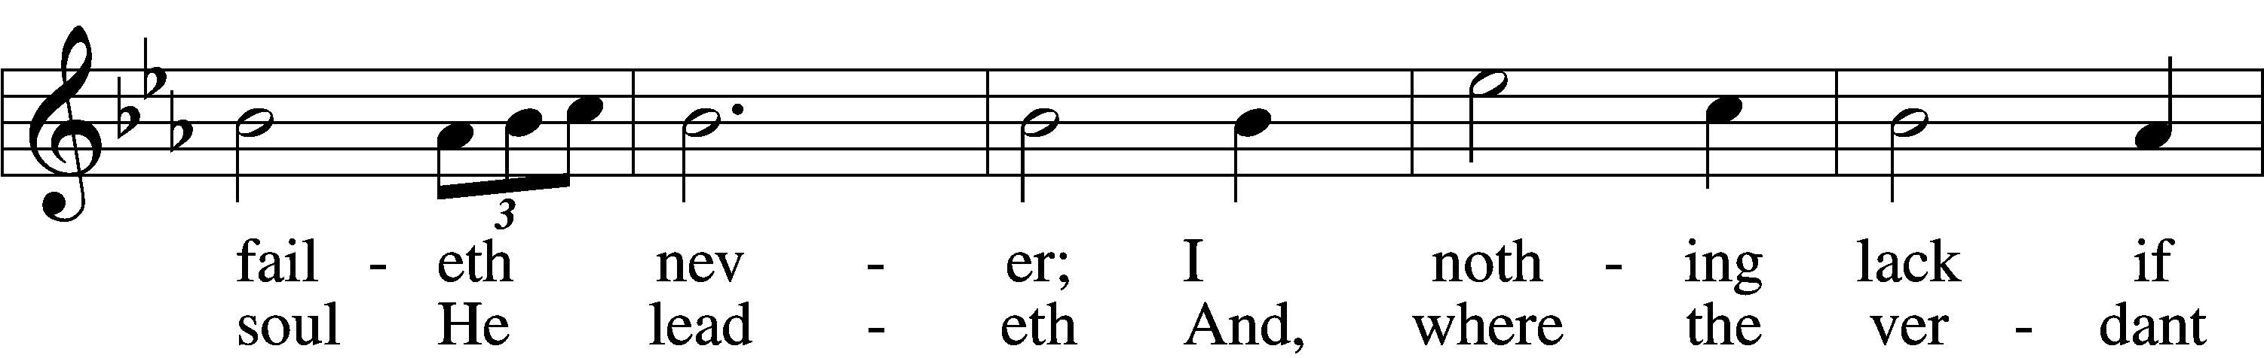
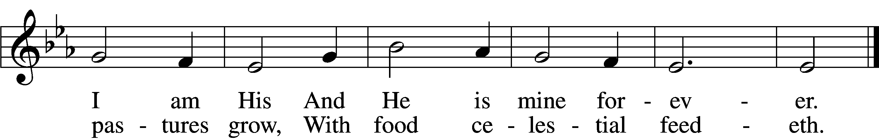
Text: Henry W. Baker, 1821–77 Tune: Irish, c. 18th cent. Text and tune: Public domain

Holy Gospel John 10:22–30
P The Holy Gospel according to St. John, the tenth chapter.
C Glory to You, O Lord.

22At that time the Feast of Dedication took place at Jerusalem. It was winter, 23and Jesus was walking in the temple, in the colonnade of Solomon. 24So the Jews gathered around him and said to him, “How long will you keep us in suspense? If you are the Christ, tell us plainly.” 25Jesus answered them, “I told you, and you do not believe. The works that I do in my Father’s name bear witness about me, 26but you do not believe because you are not part of my flock. 27My sheep hear my voice, and I know them, and they follow me. 28I give them eternal life, and they will never perish, and no one will snatch them out of my hand. 29My Father, who has given them to me, is greater than all, and no one is able to snatch them out of the Father’s hand. 30I and the Father are one.”

P This is the Gospel of the Lord.
C Praise to You, O Christ.
Gospel Processional Hymn: The King of Love My Shepherd Is LSB 709
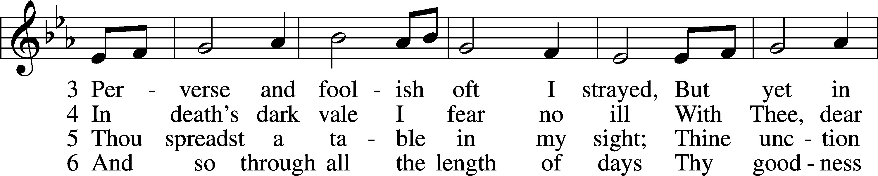
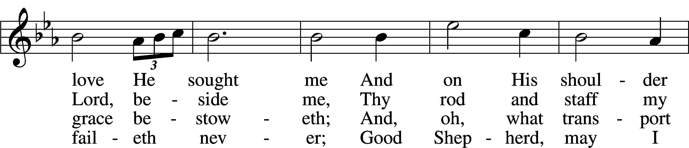
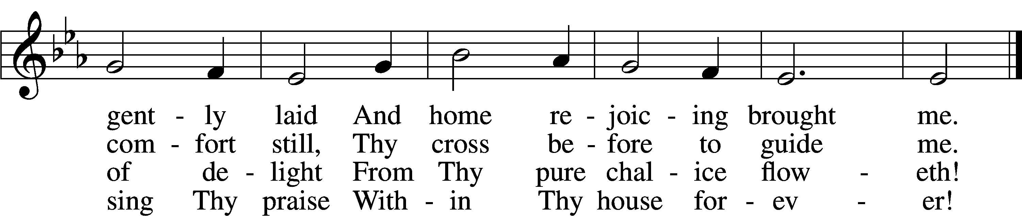
Text: Henry W. Baker, 1821–77 Tune: Irish, c. 18th cent. Text and tune: Public domain

Sit
Sermon

Stand
Nicene Creed
C I believe in one God,
the Father Almighty,
maker of heaven and earth
and of all things visible and invisible.

And in one Lord Jesus Christ,
the only-begotten Son of God,
begotten of His Father before all worlds,
God of God, Light of Light,
very God of very God,
begotten, not made,
being of one substance with the Father,
by whom all things were made;

who for us men and for our salvation came down from heaven
and was incarnate by the Holy Spirit of the virgin Mary
and was made man;
and was crucified also for us under Pontius Pilate.
He suffered and was buried.
And the third day He rose again according to the Scriptures
and ascended into heaven
and sits at the right hand of the Father.
And He will come again with glory to judge both the living and the dead,
whose kingdom will have no end.

And I believe in the Holy Spirit,
the Lord and giver of life,
who proceeds from the Father and the Son,
who with the Father and the Son together is worshiped and glorified,
who spoke by the prophets.
And I believe in one holy Christian and apostolic Church,
I acknowledge one Baptism for the remission of sins,
and I look for the resurrection of the dead
and the life T of the world to come. Amen.

Prayer of the Church

Offertory Hymn: Alleluia! Sing to Jesus LSB 821
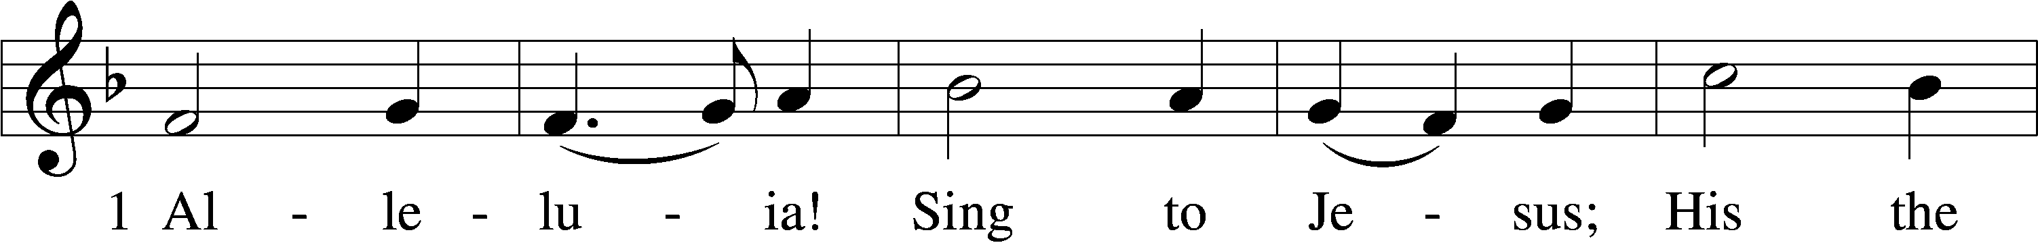
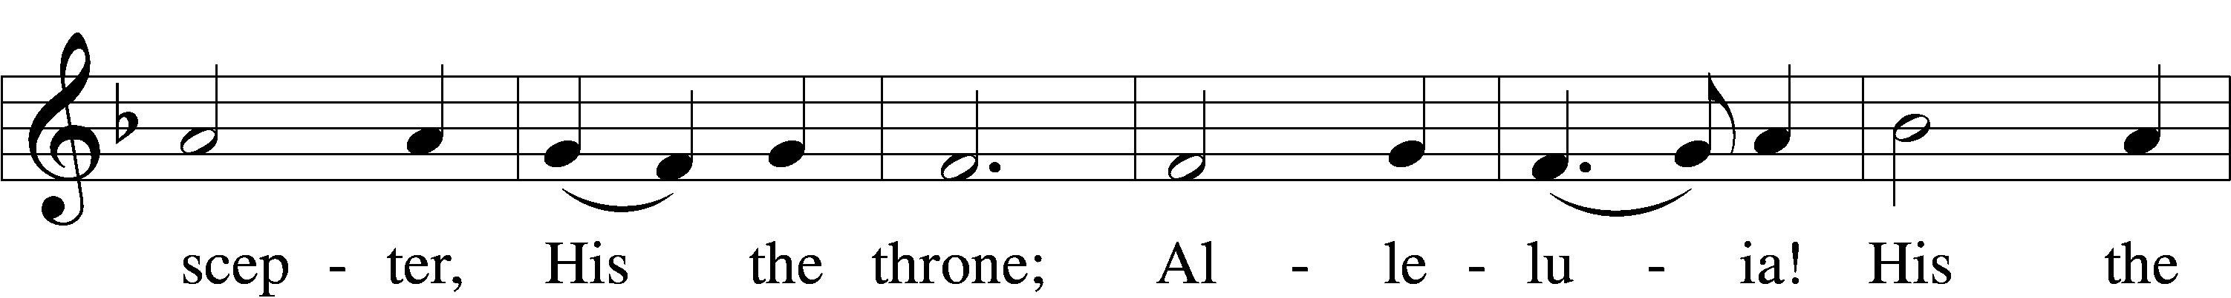
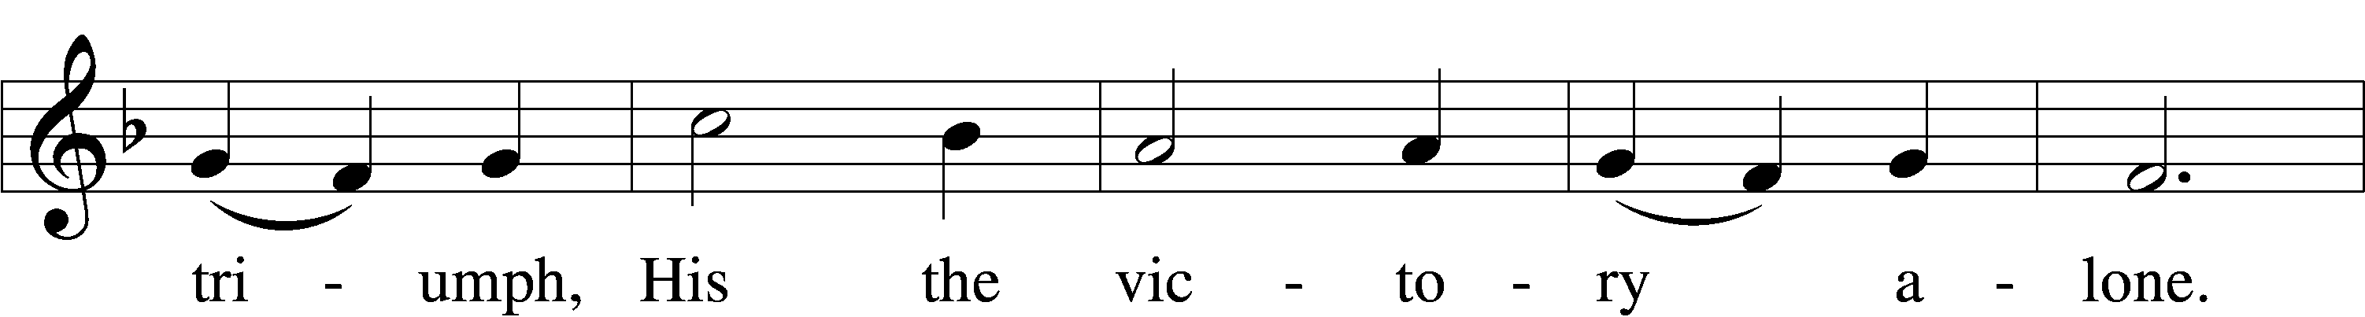
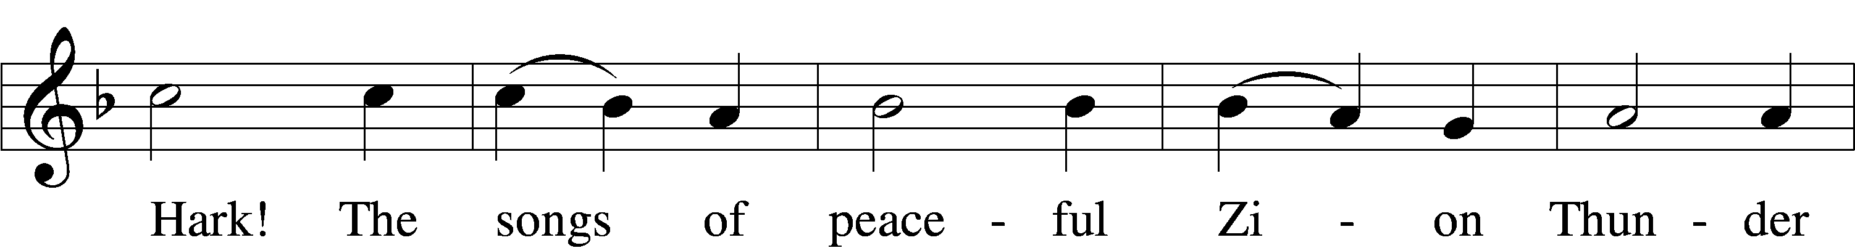
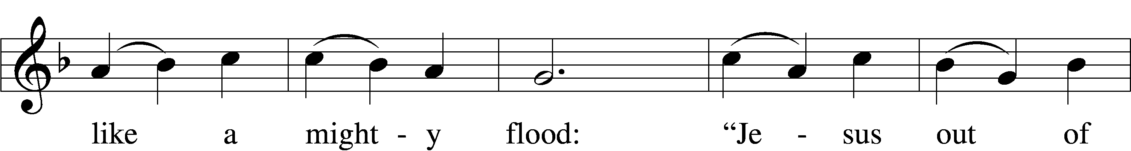
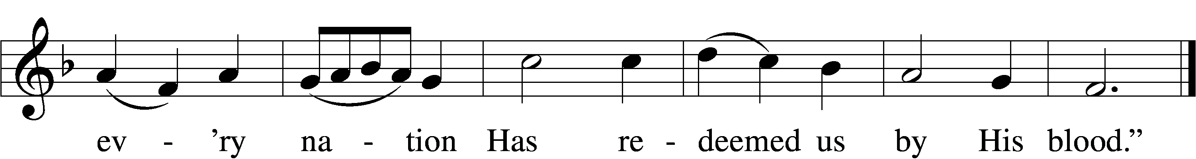
Text: William C. Dix, 1837–98, alt. Tune: Rowland H. Prichard, 1811–87 Text and tune: Public domain
Service of the Sacrament
Preface 2 Timothy 4:22; [Colossians 3:1]; [Psalm 136]
P The Lord be with you.
C And also with you.

P Lift up your hearts.
C We lift them to the Lord.

P Let us give thanks to the Lord our God.
C It is right to give Him thanks and praise.

P It is truly good, right, and salutary . . . . evermore praising You and saying:

Sanctus Isaiah 6:3; Matthew 21:9
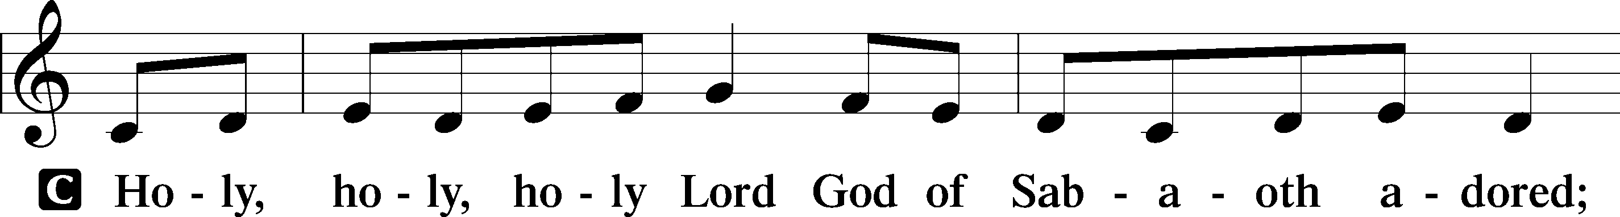
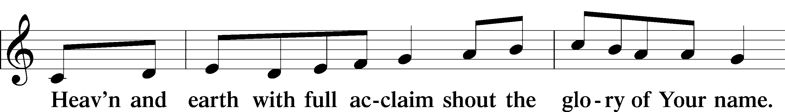
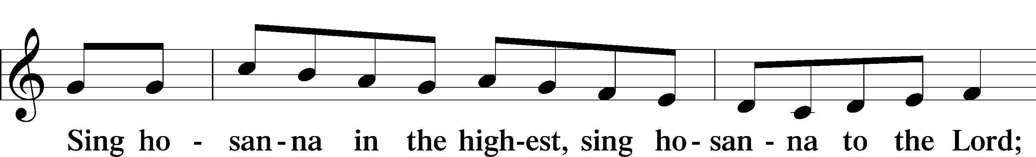
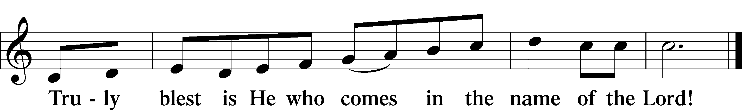
Text: Stephen P. Starke
Prayer of Thanksgiving
P Blessed are You, O Lord our God, king of all creation, for You have had mercy on us and given Your only-begotten Son that whoever believes in Him should not perish but have eternal life.

For Christ, our Passover Lamb, has been sacrificed. By His death, He has redeemed us from bondage to sin and death, and by His resurrection, He has delivered us into new life in Him.

Grant us to keep the Feast in sincerity and truth, faithfully eating His body given into death and drinking His life’s blood poured out for our salvation until we pass through death to the promised land of life eternal.

Hear us as we pray in His name and as He has taught us:

Lord’s Prayer
C Our Father who art in heaven,
hallowed be Thy name,
Thy kingdom come,
Thy will be done on earth
as it is in heaven;
give us this day our daily bread;
and forgive us our trespasses
as we forgive those
who trespass against us;
and lead us not into temptation,
but deliver us from evil.
For Thine is the kingdom
and the power and the glory
forever and ever. Amen.

The Words of Our Lord
P Our Lord Jesus Christ, on the night when He was betrayed, took bread, and when He had given thanks, He broke it and gave it to the disciples and said: “Take, eat; this is My T body, which is given for you. This do in remembrance of Me.”

In the same way also He took the cup after supper, and when He had given thanks, He gave it to them, saying: “Drink of it, all of you; this cup is the new testament in My T blood, which is shed for you for the forgiveness of sins. This do, as often as you drink it, in remembrance of Me.”
Pax Domini
P The peace of the Lord be with you always.
C Amen.

Agnus Dei John 1:29
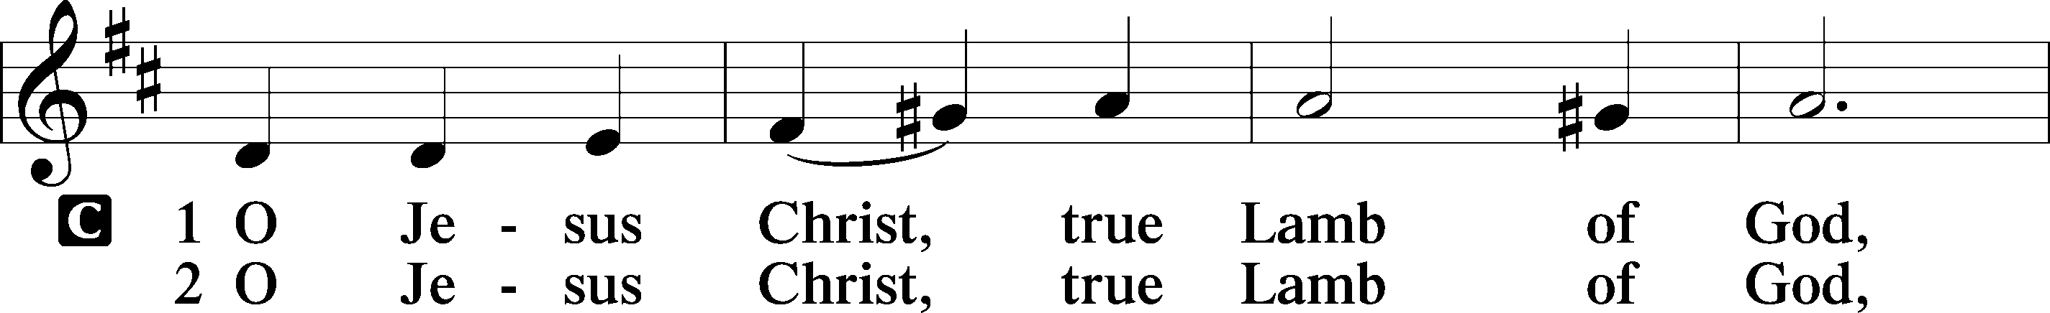
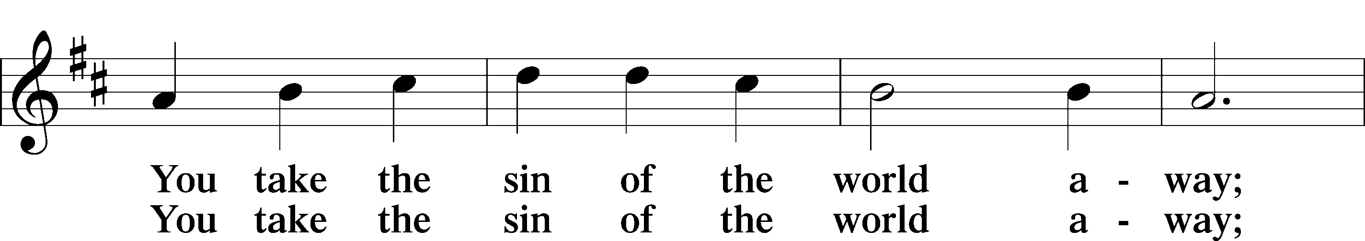
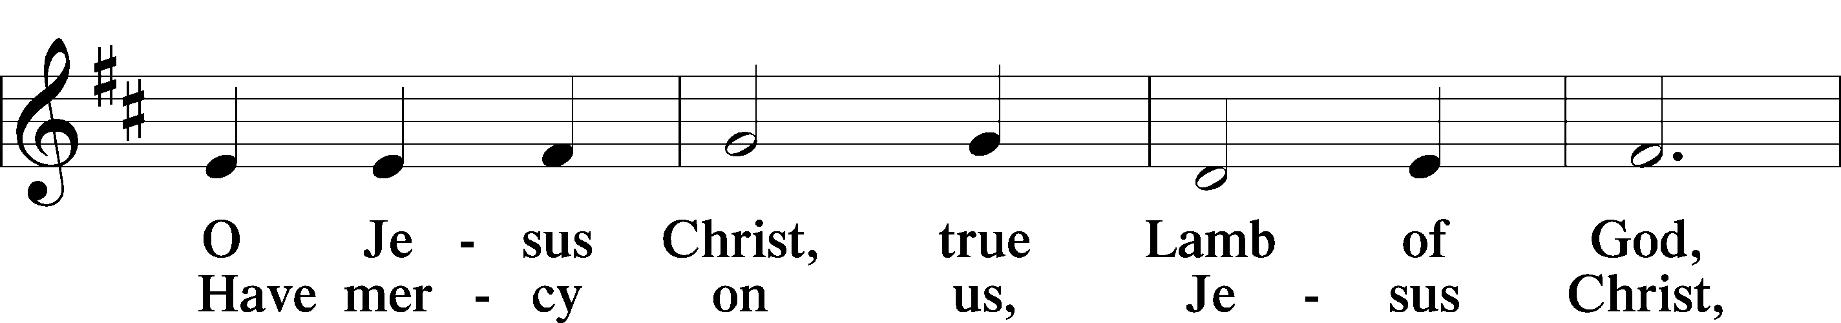
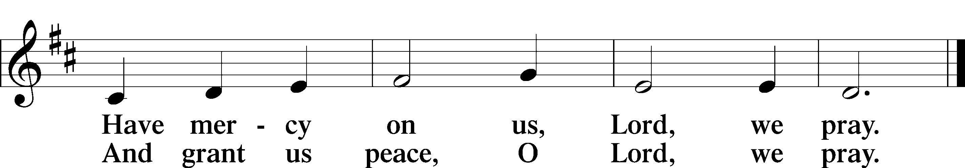
Text: Stephen P. Starke

Sit
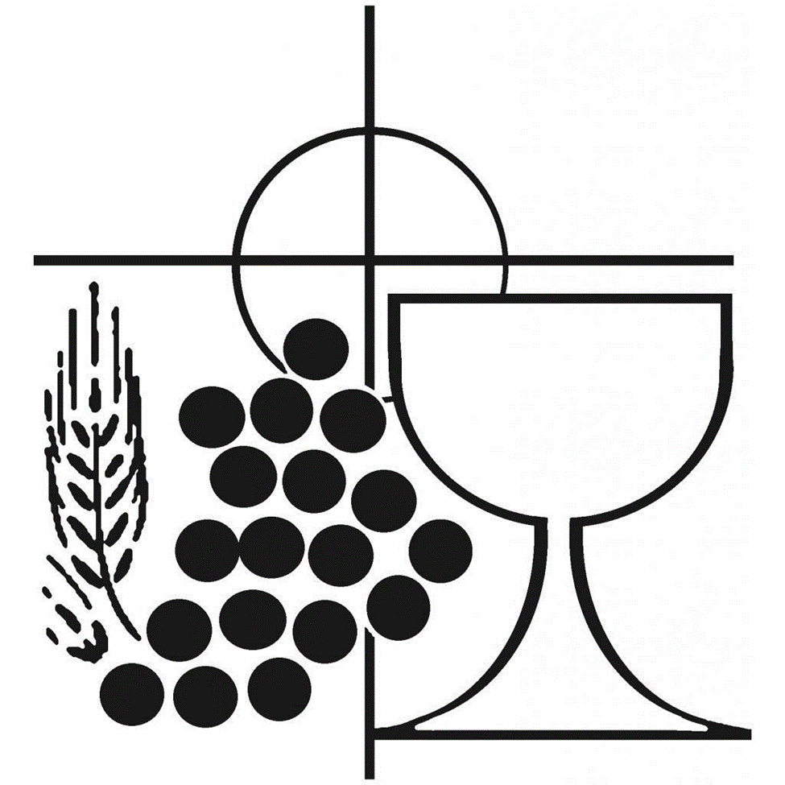

710 The Lord’s My Shepherd, I’ll Not Want LSB 710
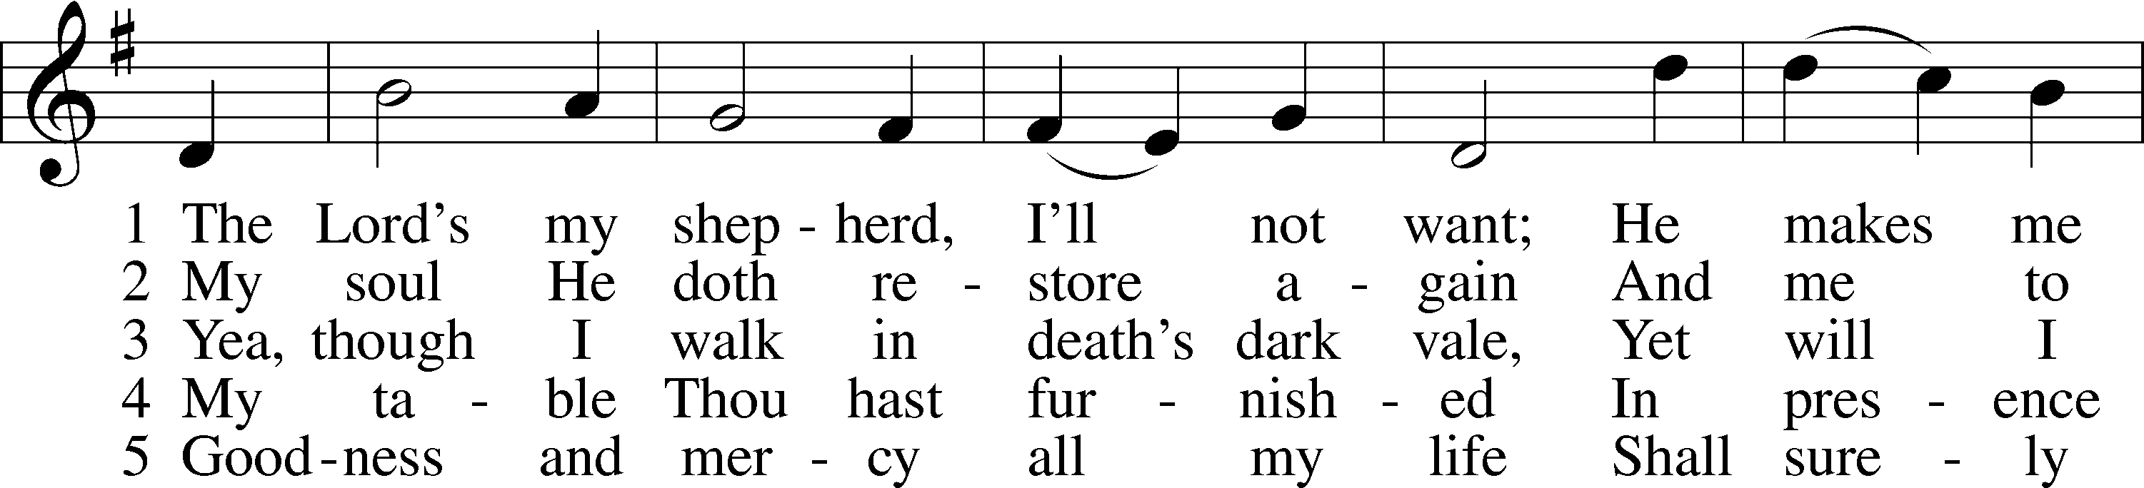
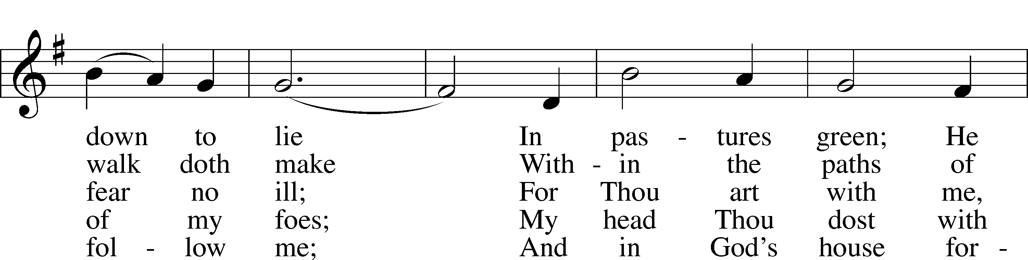
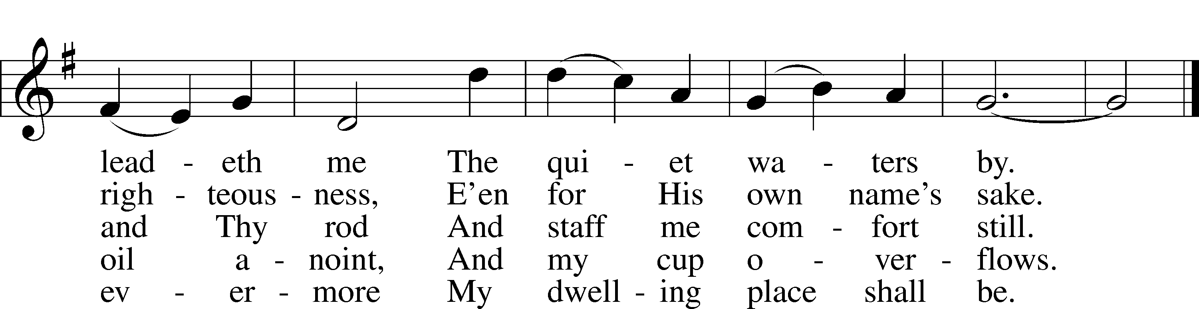
Text: The Psalms of David in Meeter, 1650, Edinburgh Tune: William Gardiner, 1770–1853
Text and tune: Public domain

735 Have No Fear, Little Flock LSB 735
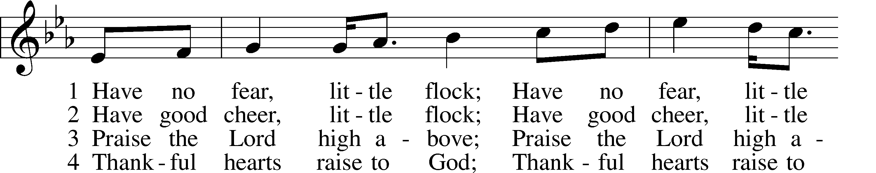
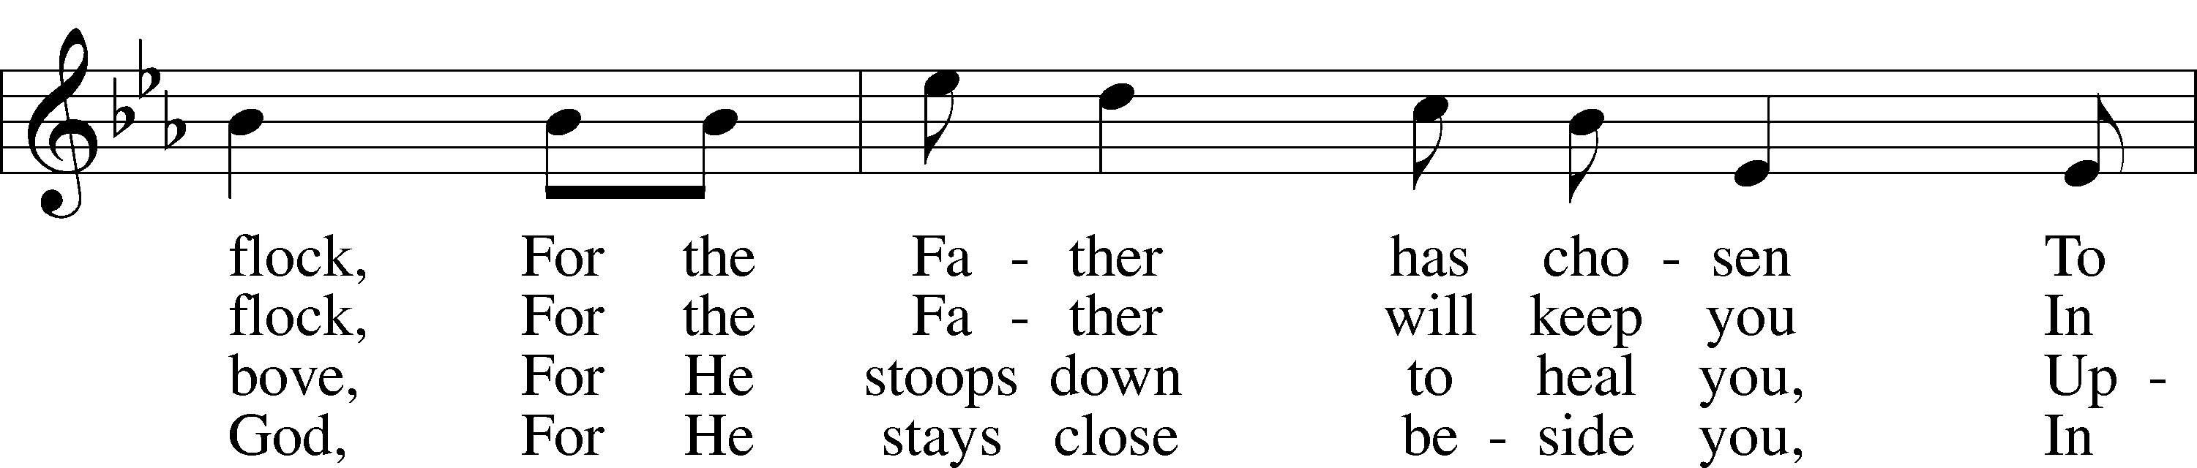
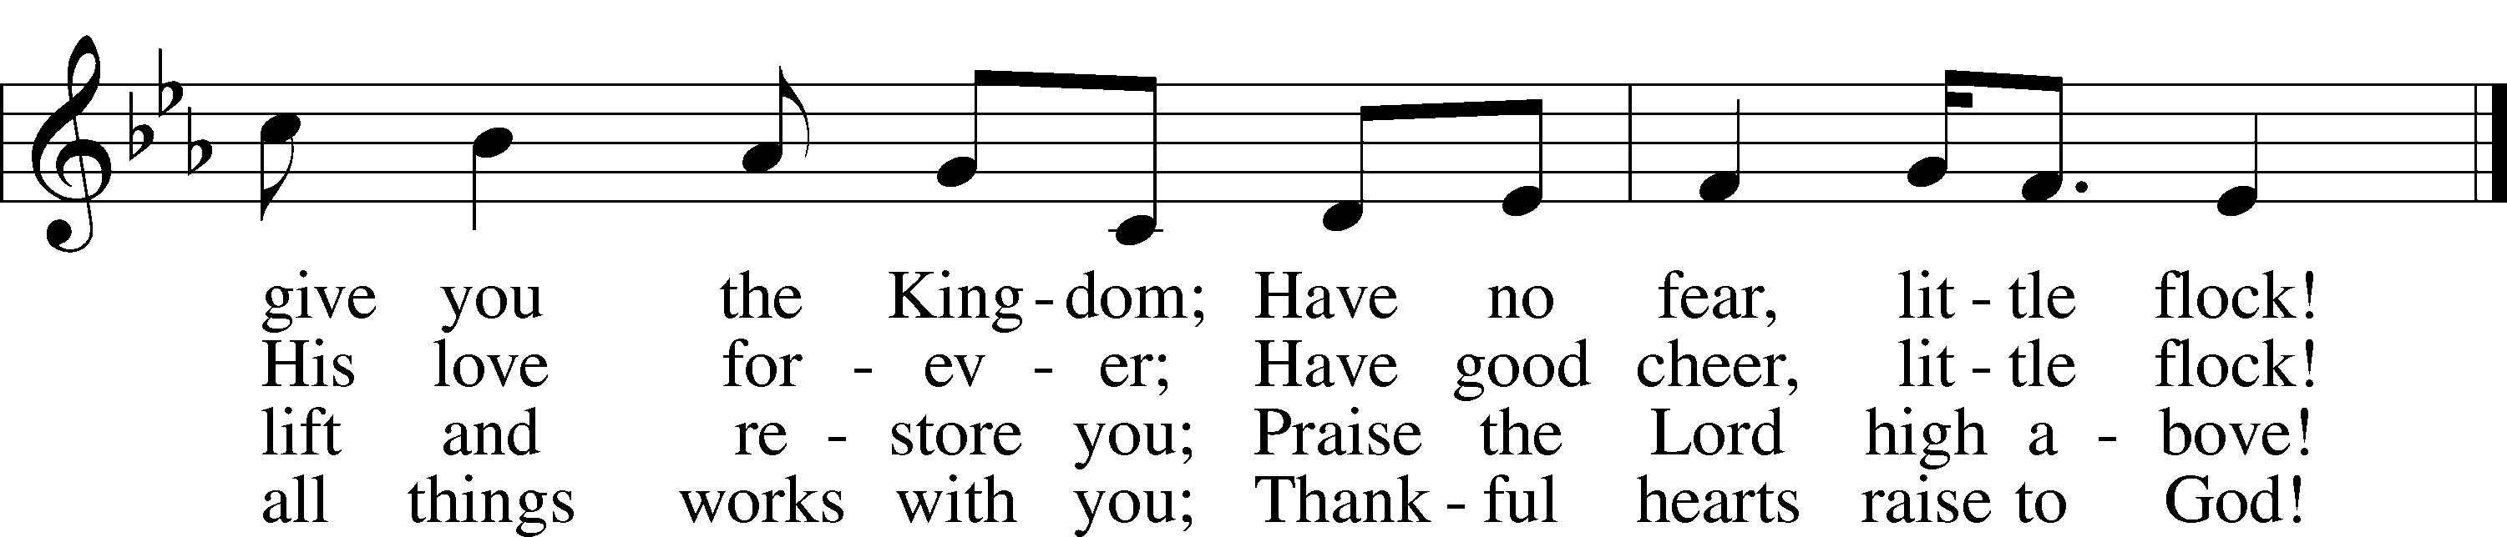
Text (sts. 2–4): Marjorie A. Jillson, 1931–2010 Text (st. 1) and tune: Heinz Werner Zimmermann, 1930
Text and tune: © 1973 Concordia Publishing House. Used by permission: LSB Hymn License no. 110002320

461 I Know That My Redeemer Lives LSB 461
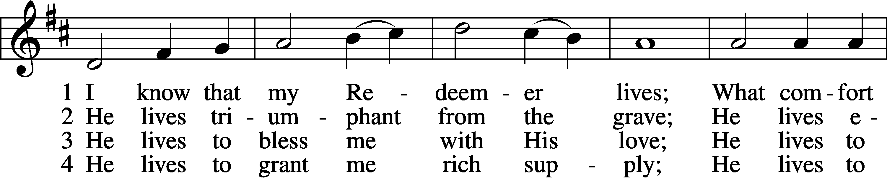
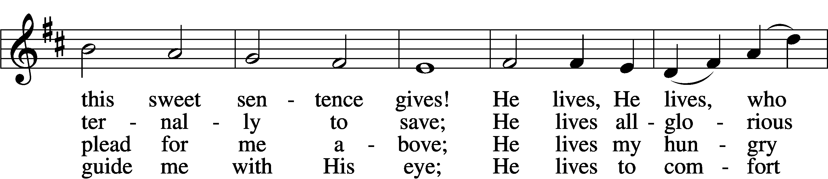
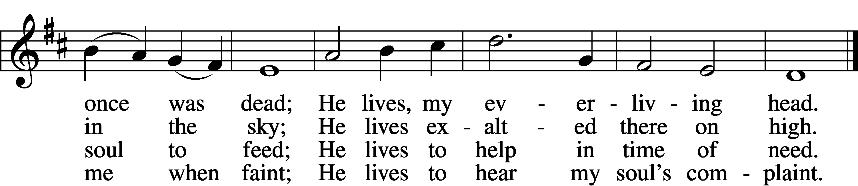

5 He lives to silence all my fears;
He lives to wipe away my tears;
He lives to calm my troubled heart;
He lives all blessings to impart.

6 He lives, my kind, wise, heav’nly friend;
He lives and loves me to the end;
He lives, and while He lives, I’ll sing;
He lives, my Prophet, Priest, and King.
7 He lives and grants me daily breath;
He lives, and I shall conquer death;
He lives my mansion to prepare;
He lives to bring me safely there.

8 He lives, all glory to His name!
He lives, my Jesus, still the same;
Oh, the sweet joy this sentence gives:
I know that my Redeemer lives!

Text: Samuel Medley, 1738–99, abr.
Tune: attr. John C. Hatton, d. 1793
Text and tune: Public domain
Stand
Post-Communion Hymn: Alleluia! Jesus Is Risen LSB 474
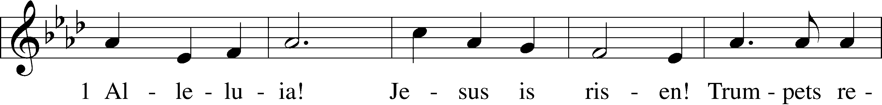
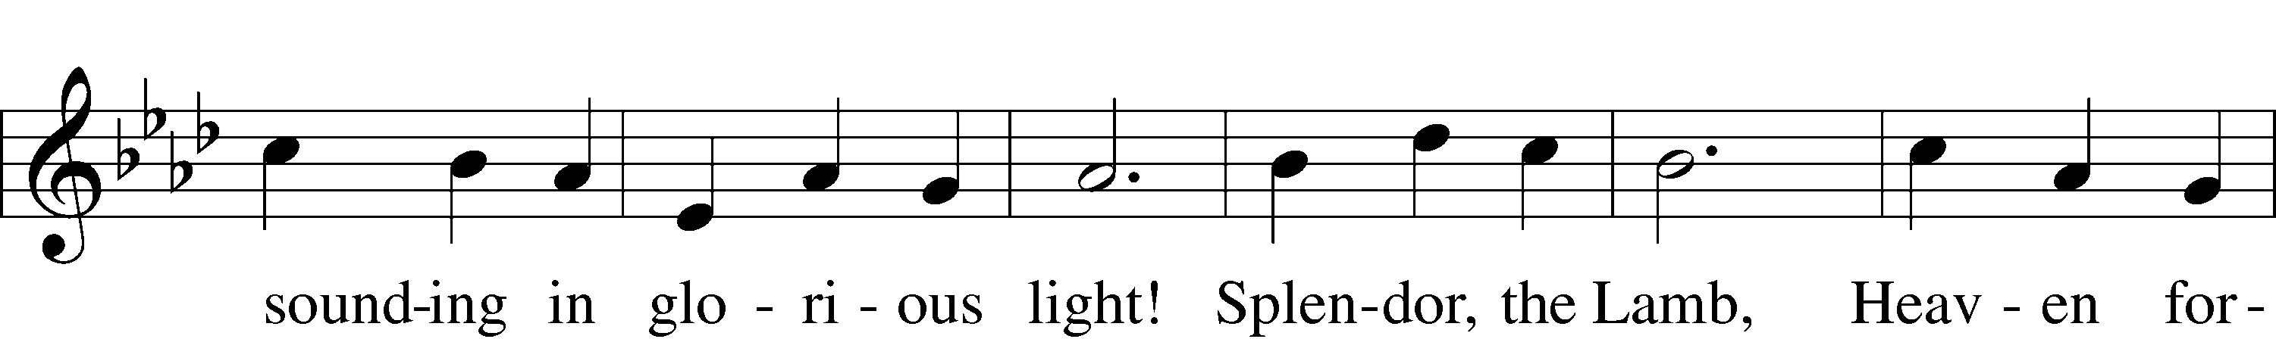
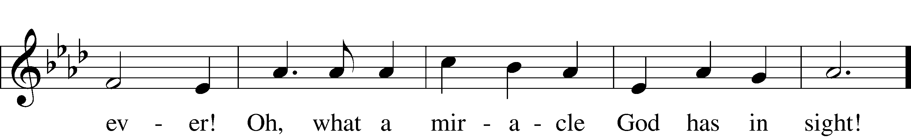
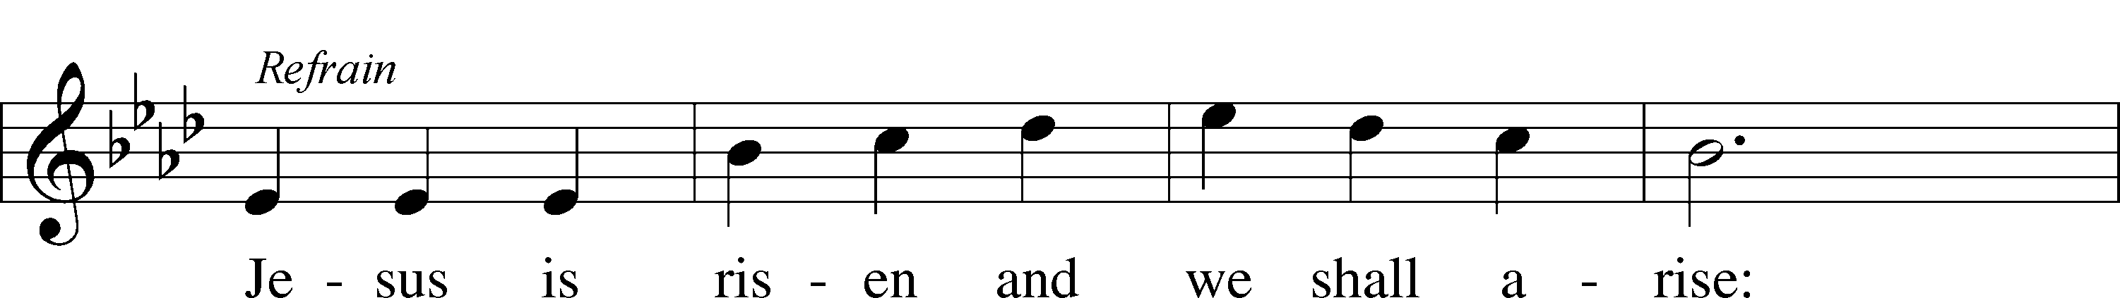
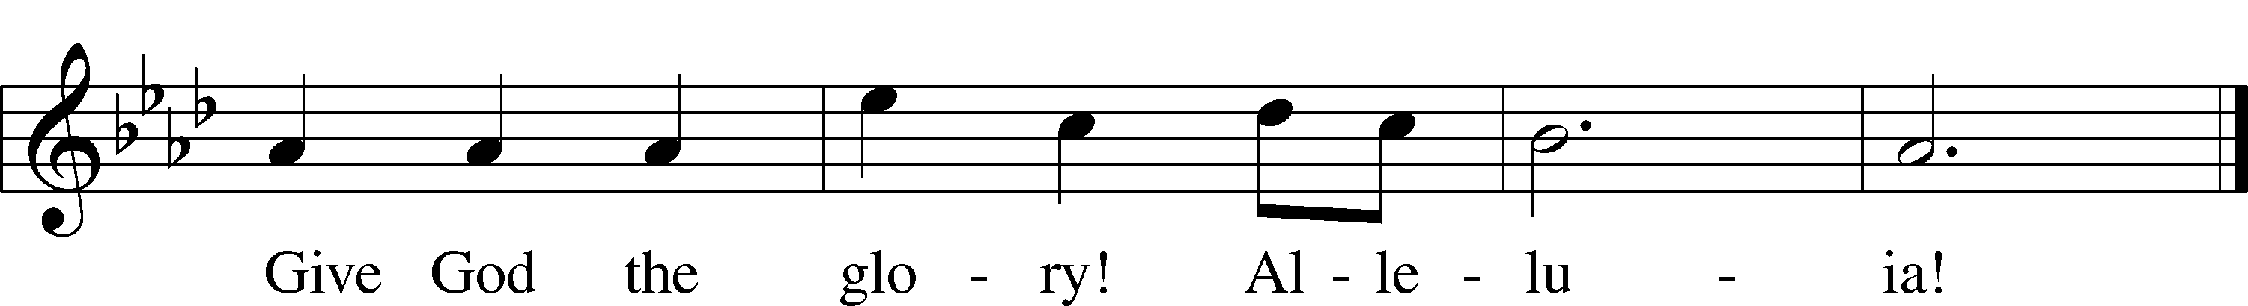
Text: Herbert F. Brokering, 1926–2009 Tune: David N. Johnson, 1922–87
Text: © 1995 Augsburg Fortress. Used by permission: LSB Hymn License no. 110002320
Tune: © 1968 Augsburg Publishing House. Used by permission: LSB Hymn License no. 110002320

Post-Communion Collect
A Let us pray. . . .
C Amen.

Benedicamus Psalm 103:1
A Let us bless the Lord.
C Thanks be to God.

Benediction
P The Lord bless you and keep you.
The Lord make His face shine on you and be gracious to you.
The Lord look upon you with favor and T give you peace.
C Amen.

725 Children of the Heavenly Father LSB 725
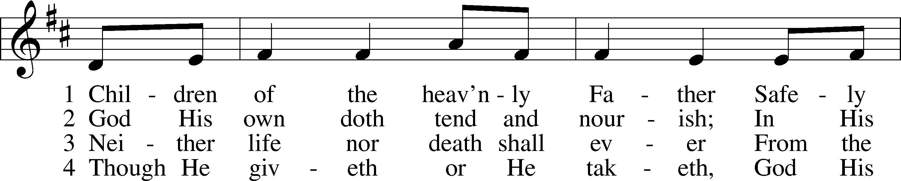
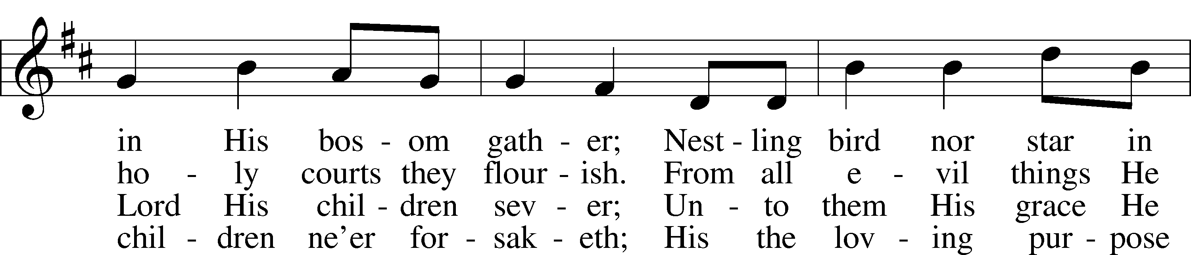
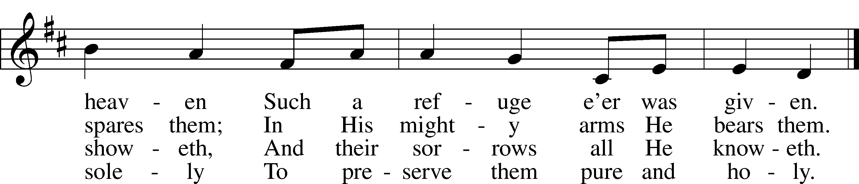
Text: Carolina Sandell Berg, 1832–1903; tr. Ernst W. Olson, 1870–1958 Tune: Lofsånger och andeliga wisor, 1873, Sweden
Text: Public domain Tune: Public domain

Dismissal

Postlude: I Know That My Redeemer Lives! Wilbur Held

Acknowledgments
Unless otherwise indicated, Scripture quotations are from the ESV® Bible (The Holy Bible, English Standard Version®), copyright © 2001 by Crossway, a publishing ministry of Good News Publishers. Used by permission. All rights reserved.
Created by Lutheran Service Builder © 2022 Concordia Publishing House.
News & Notes
Altar Flowers
Flowers on the altar today are given by Carolyn Louden in memory of her mother, Audrey Neubert, on Mother’s Day. Flowers are also given by the Dungey Family in celebration of Sadie’s 15th birthday.
The Great Sending
The 39th Convention of the Southeastern District of the LCMS begins tomorrow. Please keep the convention and the participants in your prayers this week. All members are invited to join the first three sessions online. You will find a link to sign up for the sessions in the May Newsletter. Pastor Alms and JB Jaeger will be attending the convention in person on Thursday and Friday. Thank you JB for representing our congregation.

Outdoor Worship and Church Picnic
Mark your calendars for Sunday, May 22nd. Don’t go to church that Sunday, go to the park! There will be no Sunday School or Bible Class on that day. We will gather at Shelter 706 at the Pickall Area of Patapsco Valley State Park. Dress casual and stay for picnic fun after the service. This is a church and school event! Please bring a side to share.
Vacation Bible School
Plans are underway for our first VBS in over 2 years, so let’s make it an extra special experience! VBS will be held August 1- 5. If you can volunteer with planning, preparation work, teaching that week, or helping in any other way, please contact Kirsten Hall at Kirsten.hall@splscatonsville.org.
Bell Choir
Did you know that St. Paul is the proud owner of a set of bells? Wouldn’t it be great to hear them played in worship? If you’ve ever considered working with ding dongs, how about leading up the Bell Choir? All interested volunteers, please contact Pastor Alms.
Oromo Fellowship
The Oromo congregation will begin to meet in person again today! Their services will be at 11:45 in the sanctuary. Please be mindful as we move about the church on Sunday mornings.
Summer Mission Trip
The Mission Trip is set for June 19th through 24th in Western Kentucky. We will be working with Samaritan's Purse rebuilding houses impacted by the recent tornadoes. If you are interested in joining us, there are four more slots available. Talk to Pastor Alms for more information or email him at almspg@gmail.com .

Lutheran Books and Beer
Next meeting to discuss The Spirituality of the Cross by Gene Edward Veith will be on Thursday, May 19th at 7 pm. Bring your book and meet at The Rathskeller, a local German restaurant, for discussion and fellowship.
Looking for summer opportunities?
St. Paul Early Childhood Center is looking for youth ages 13 and over who want to earn volunteer hours during the summer. Have fun interacting with the children in their day-to-day activities. If you can commit to 2-3 days/week, please contact Ms. Ama at ama.owusu@splscatonsville.org or call the school at 410-747-1924. Hours are flexible.
Bulletin Recycling
Because St. Paul is considered a “business,” the local recycling trucks do not pick up recycling from the church. The bulletins that are left in the back of the church get thrown into the trash on Monday morning. Please consider taking your bulletin home to recycle. (After you post the prayer list on your fridge so you can be reminded to keep others in prayer!)
Serving at St. Paul
 | This week | Next week
Cantor | Jim Baeder | Jim Baeder
Reader | Michelle Johnson | JB Jaeger
Greeter | Bruce Staudinger | Doris Schascheck
Usher | Jim Kyne | Roy Krakat
Usher | David Nguyen | Jim Baeder
Acolyte | Michael Hemmeter | Paul Baeder
Daily Readings: May 8: Lev 8:1–13, 30–36, Luke 9:1–17; May 9: Lev 9:1–24, Luke 9:18–36; May 10: Lev 10:1–20, Luke 9:37–62; May 11: Lev 16:1–24, Luke 10:1–22; May 12: Lev 17:1–16, Luke 10:23–42; May 13: Lev 18:1–7, 20—19:8, Luke 11:1–13; May 14: Lev 19:9–18, 26–37, Luke 11:14–36.
Prayer List
CHURCH MEMBERS
John & Dina Dornbusch (returning from Madagascar)
Michael and Karen Puls (recovering from Covid)
Paula Staudinger (dealing with chronic illness)
Lindsey Gay (at home, prayers that medical treatment will be timely and successful)
Lindsey, Janice, and John Gay (strength, stamina, and hope to get through this rough time)
John Gay (colon cancer)
Sam Oldhouser (home recovering from colitis)
Bruce Staudinger (strength and grace as he cares for Paula)
Steve Hoffman (recovering from surgery)
Marilyn Haberl (dealing with scleroderma)
Linda Cook (relief from severe pain)
SHUT-INS
Libby Cruey, Mildred Klein, Betty Blackburn, and Janet Conklin.
FAMILY AND FRIENDS
The SED Convention and participants (good decisions and safe travels)
Reychel Lauren Reynolds and parents Timothy and Keila Reynolds in Yuma, Az., thanksgiving for the 4th great-grandchild of Ken and Joyce Waibel, born on April 30th
The people of Ukraine and an end to the war in Ukraine
Mason Ruzika, son of school secretary Sara (recovering from a concussion) 5/8
Ashley Ruzika, daughter of Sara (recovering from knee surgery) 5/1
John Kassouf, former principal of St. Paul School (stage 4 prostate cancer) 4/17
Anita Cohen (thanksgiving for a clear cancer scan) 4/17
Claudia Kyne, daughter-in-law of Jim and Laverne (having kidney problems) 4/3
Myrtle Oliver, mother of Ray Fields (that chemo treatments will be successful) 4/3
Michelle McMorris, teacher in our ECC (battling breast cancer) 5/1
Brenna, 3 year old daughter of Bonnie, a teacher at St. Paul’s Glen Burnie (inoperable brain tumor)

Prayer is a great gift and privilege for Christians. To add people to the prayer list, please email pastoralms@stpaulcatonsville.org or dana.stigdon@splscatonsville.org or call the church office. Family and friends will automatically be removed after one month. If you want your request to stay on for another month, just contact the office.

